Repeatable read
First transaction
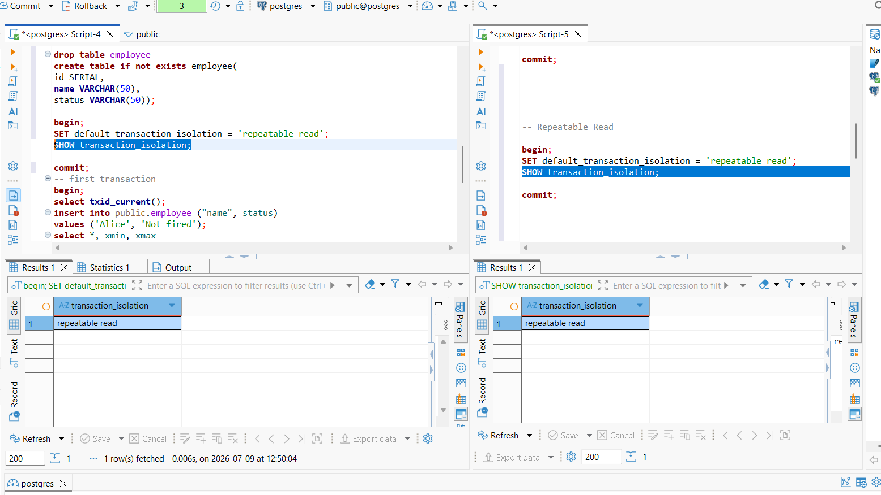
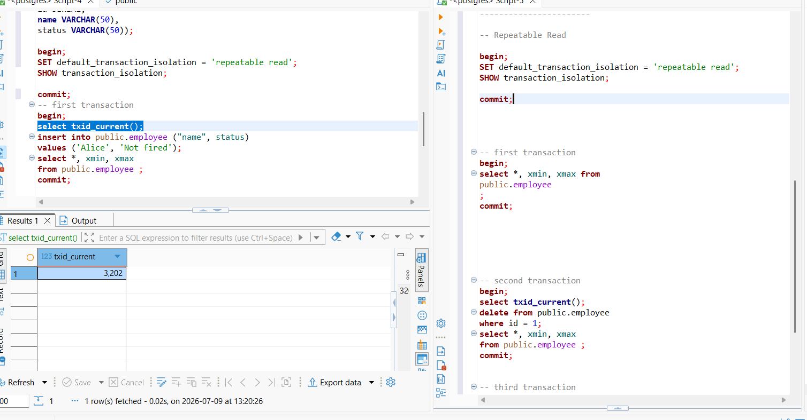
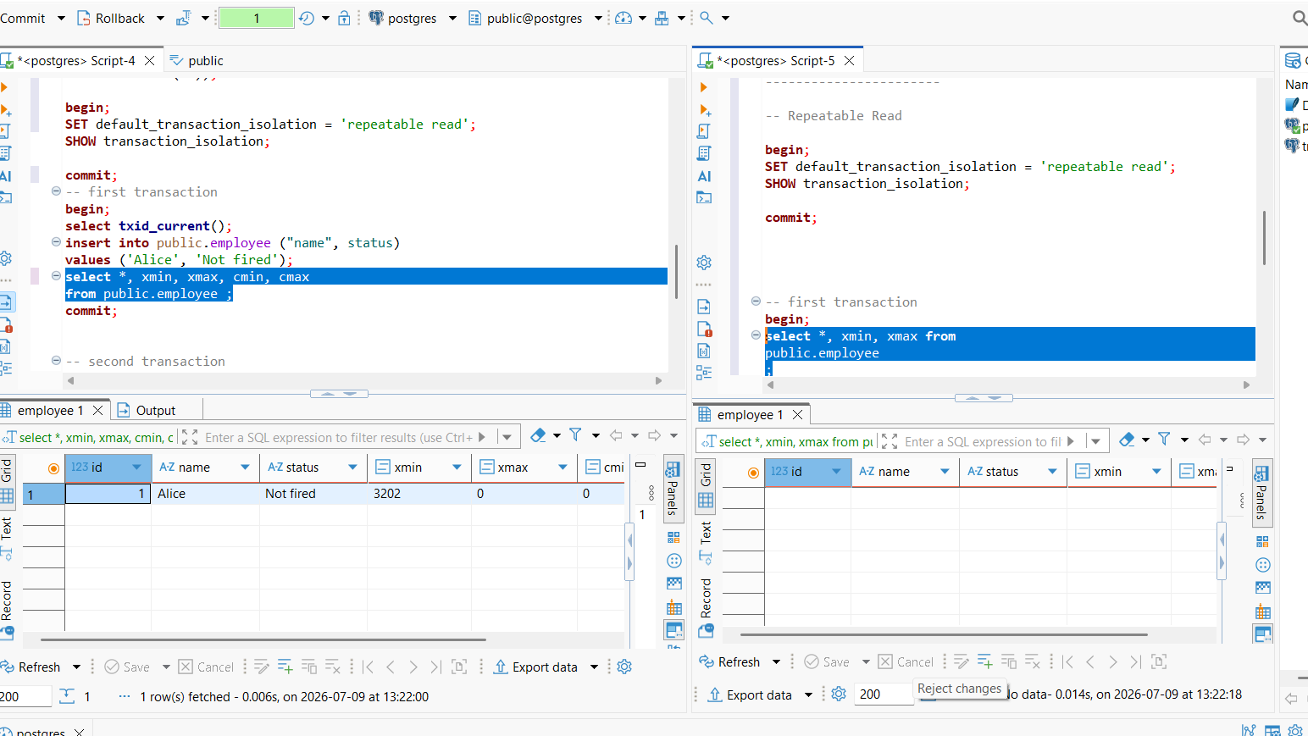
After 1 session commit
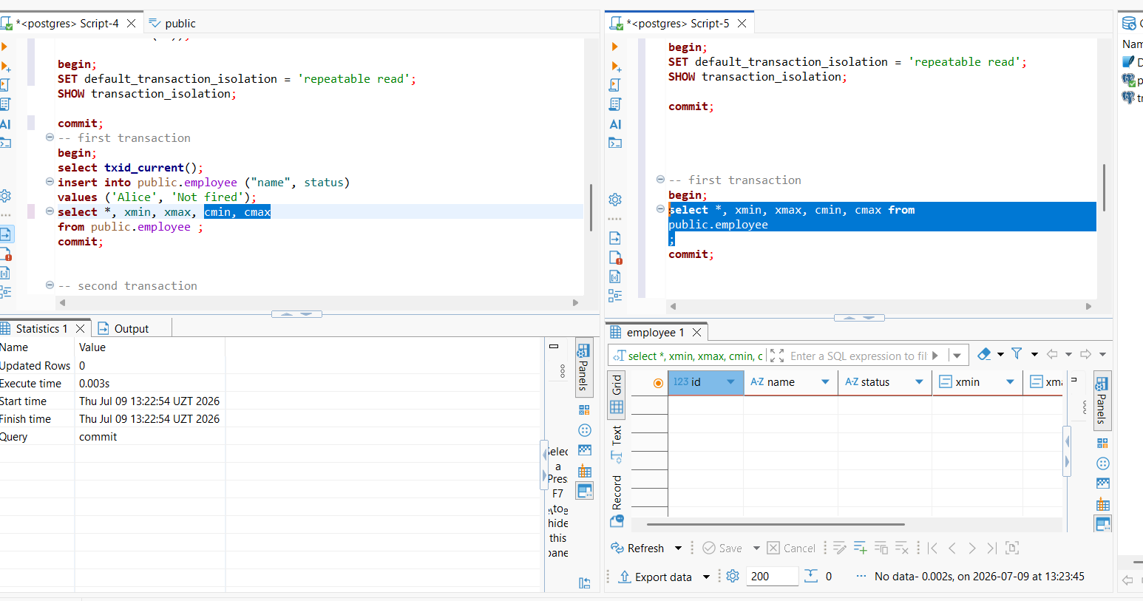

Because Session 2 keeps using the same snapshot it took when the transaction started.
It does not see changes committed after that.

After 2 session commit:

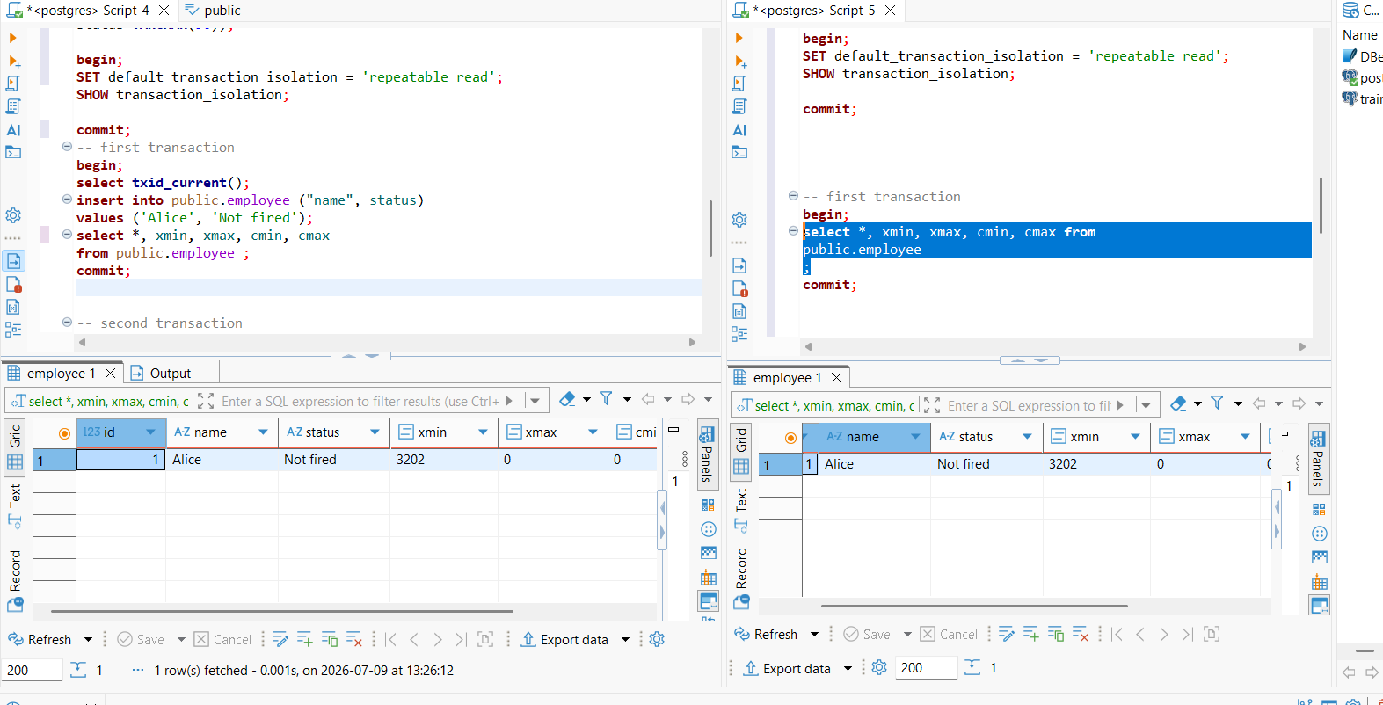
in repeatable read we cannot see new added lines that are committed in 1 session until we commit the 2 session

Second transaction
After deleting:
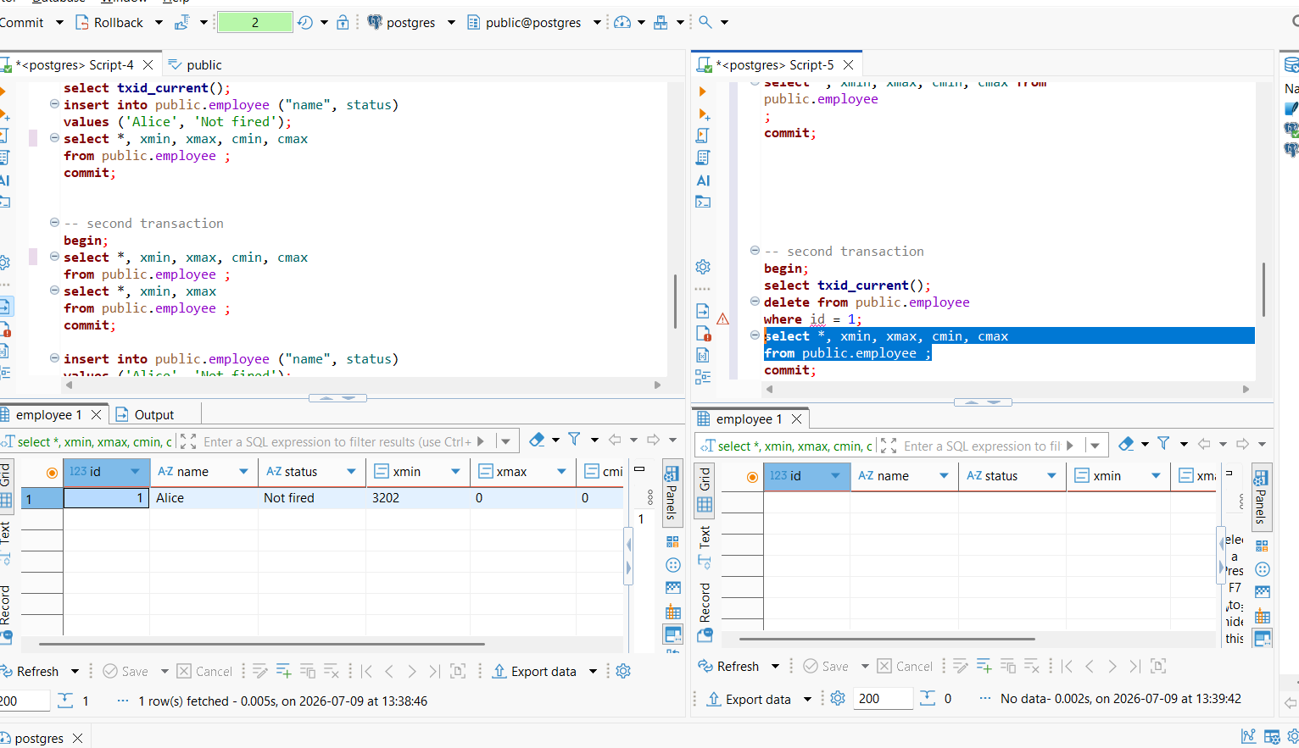

After 2 session commit, we still can the row in 1 session
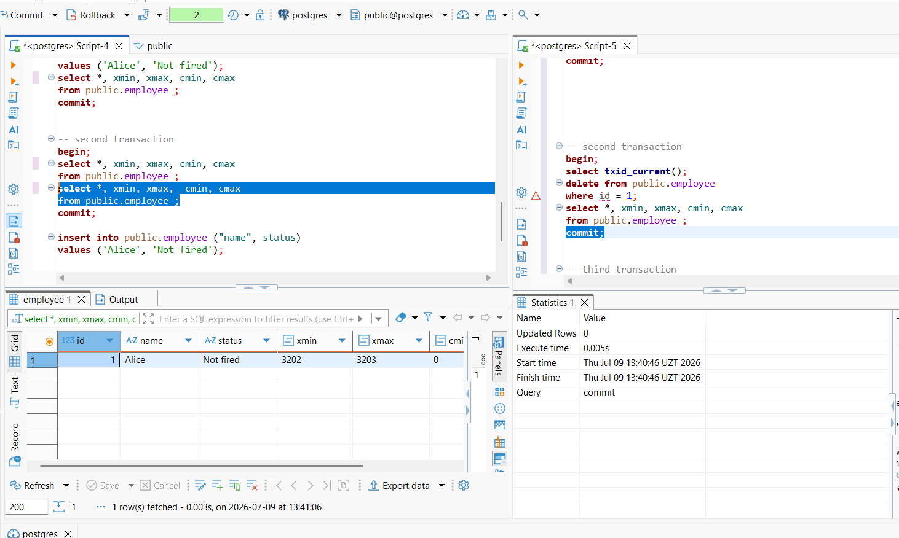
After 1 session commit
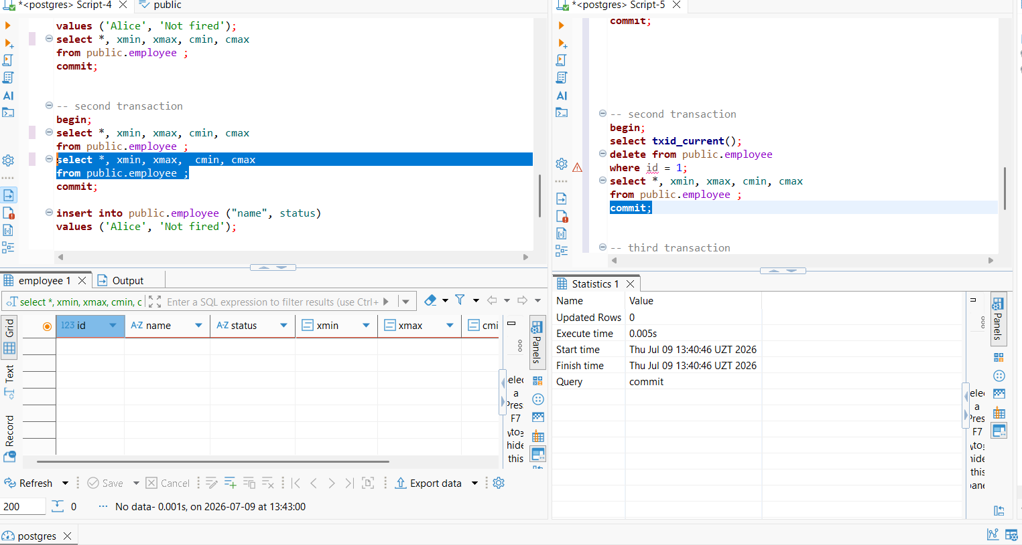

Third transaction
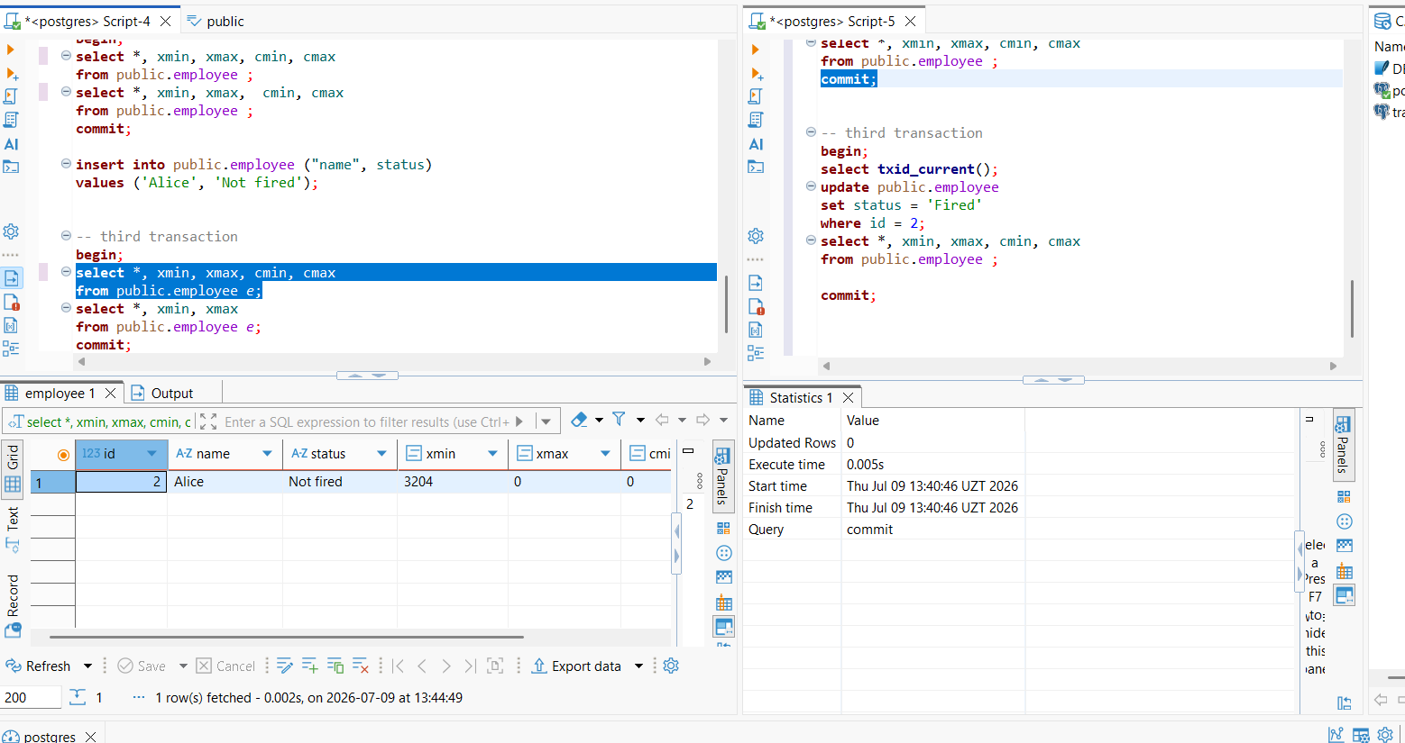

After update and commit in 2 session
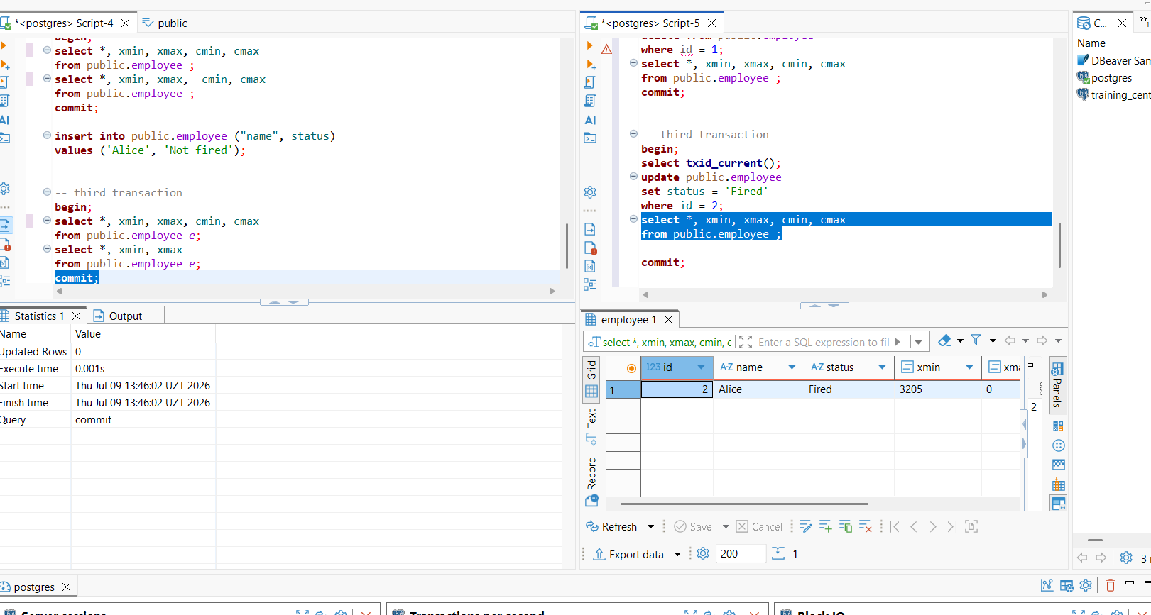

After commit in 1 session
